**Day 7**

1. Rank employees by their total sales

(Total sales = Total no of orders handled, JOIN employees and orders table)

Query:

select e.employee_id, e.first_name || '_' || e.last_name AS employee_name,

Count(o.order_id) as total_orders,

Rank() Over (Order by count(o.order_id) desc) as sales_rank

from employees e

join orders o ON e.employee_id = o.employee_id

group by e.employee_id, e.first_name, e.last_name

order by sales_rank

Output:

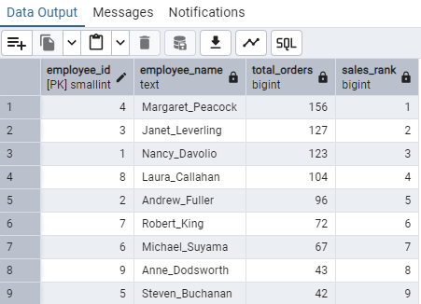

2. Compare current order's freight with previous and next order for each customer.

(Display order_id, customer_id, order_date, freight,

Use lead(freight) and lag(freight).

Query:

select o.order_id,

c.customer_id,

o.order_date,

o.freight,

lag(o.freight)over(partition by c.customer_id order by o.order_date) as previous_order,

lead(o.freight) over(partition by c.customer_id order by o.order_date) as next_order

from customers c

join orders o ON c.customer_id = o.customer_id

order by c.customer_id,o.order_id

Output:

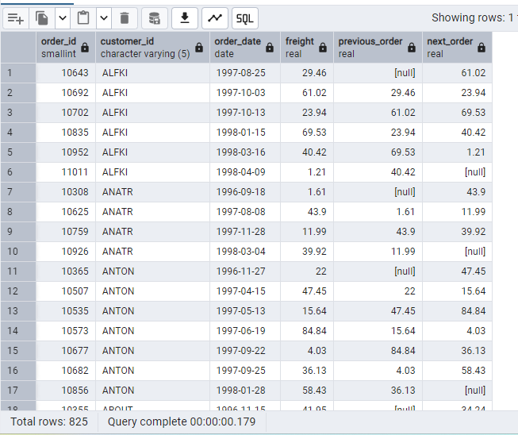

3. Show products and their price categories, product count in each category, avg price:

(HINT:Create a CTE which should have price_category definition:

WHEN unit_price < 20 THEN 'Low Price'

WHEN unit_price < 50 THEN 'Medium Price'

ELSE 'High Price'

· In the main query display: price_category, product_count in each price_category, ROUND(AVG(unit_price)::numeric, 2) as avg_price)

Query:

with price_category_cte as(

select product_id,product_name,unit_price,

case

when unit_price< 20 then 'LOW Price'

when unit_price < 50 THEN 'Medium Price'

Else 'High Price' end as Price_category

from products

)

--main query--

select price_category, count(product_id) as product_count, ROUND(AVG(unit_price)::numeric, 2) AS avg_price

from price_category_cte

group by price_category

order by price_category

Output:

